# Attendance Tracker

## Google Sheets interface

### Google sheets limits

#### Workbooks

10 million cells

18,278 columns

200 sheets

Update 40,000 rows at once

#### Data transfer

Read requests

300 per minute per project  
 60 per minute per user per project * (This is effectively the limit for attendance tracker)  
Write requests

300 per minute per project  
 60 per minute per user per project * (This is effectively the limit for attendance tracker)

## Introduction

Attendance tracker is a simple Python program to track the attendance of students, mentors, coaches and volunteers to/from events for the purpose of being able to note hours given to our local community.

This tracker does NOT track any precise location data other than a generic tag such as “Workshop”, “RoughRiders 2025”, “Library June 2025” etc..

Data collected is stored locally on each ‘device’ that has been given access to the ‘Track Database’. Optionally the data can be stored on a Google Sheet workbook (to allow multiple ‘devices’ to access at the same time) and optionally in a github repository. Both Google Sheets access and github access should be configured accordingly to ensure the data is not exposed outside the organizational requirements. (i.e. DO NOT MAKE THE github repository public!!!). Encryption of the local and github data is currently on the list of things to do. The Google Sheet is purposely NOT encrypted in order to allow data processing within the Google environment but should have sufficient protections implicit in the google workflow.

The ‘Track Database’ contains a unique ID for each ‘trackable member’ along with their name (for display purposes) and optionally a photo.jpg display image.

### Features

The attendance tracker is meant to be a simple to setup/configure, simple to operate real time attendance tracking system for small organizations. The initial design requirements are as follows…

#### Primary features

1. Support 300+ members
2. Support multiple simultaneous ‘devices’ to allow multiple entry points to the facility
3. Be as quick and easy as possible to sign in/out
4. Somewhat ‘fun’ to interact with
5. Support RFID tags for quick processing
6. Support easy data processing for reports etc…
7. Provide basic administration features
8. Able to operate without additional accounts/servers/fees etc… (depending on features needed)
9. Be reasonable cheap to build (will work on Windows but also Raspberry Pi with LCD)
10. Be open source, expandable and available for anyone to implement

#### Secondary features

1. Support off site events (remote, portable device that can sync in real time or at a later time)

### Is not…

The attendance tracker is not meant to be a fully featured, all singing, all dancing access tracker. Other options available seem to cost many $100s (even $1000s!!) and/or require provider accounts, server costs etc… It is not massively complex, does not inherently provide any data analysis

## Setup

### Python

“Attendance Tracker” is written in the widely available and cross platform programming language “Python”. Most Linux systems, including the Raspberry Pi platform, will have Python installed by default, but Windows systems may not.

Whilst Attendance Tracker was developed primarily on a Windows computer, it was actually designed to run on a Raspberry Pi Zero W with an LCD touch screen and RFID card reader attached. This means that Attendance Tracker can actually be used on a Windows computer, but may not feel quite as integrated as when running on a Raspberry Pi system.

#### Installing Python on Windows (optional)

If you wish to run Attendance Tracker on Windows you can check if Python is installed by doing the following…

In Windows search type “cmd”. You should see the following appear…

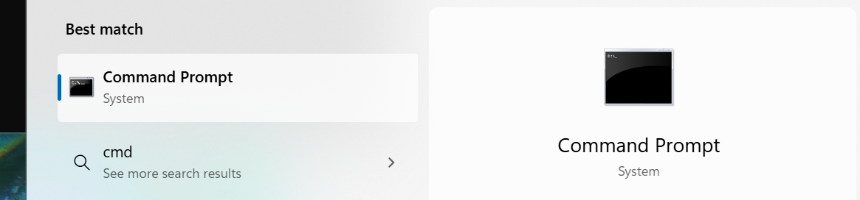

Simply hit the enter key and the following should appear…

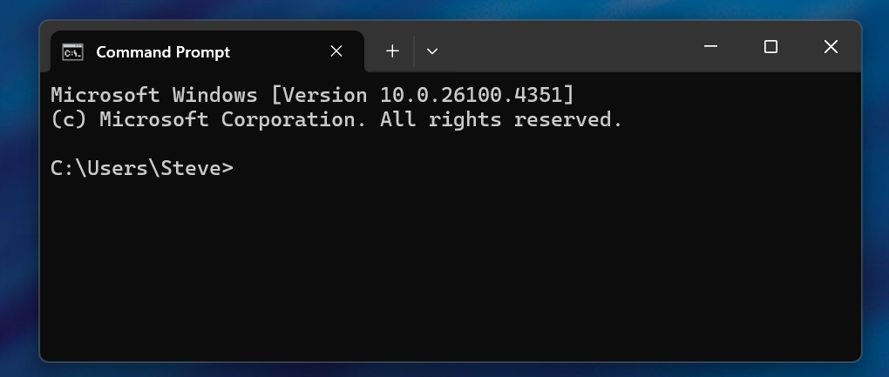

With this new window highlighted type “python –version”. If Python is installed then you should see something similar to the following…

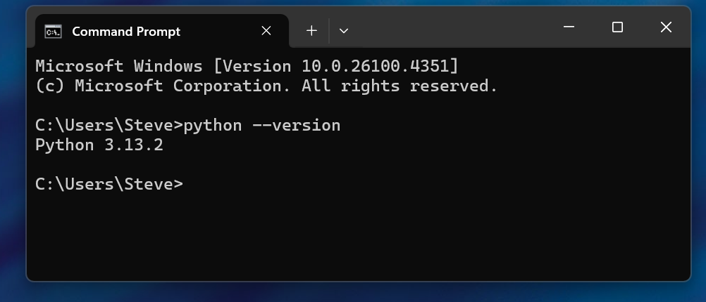

This tells us that Python version 3.13.2 is installed.

Attendance Tracker requires Python version 3.10.7 or later.

If Python is not installed, or the version is lower than V3.13 then visit the Python community web page at <https://www.python.org>, select “downloads”, then download the latest version. Once downloaded run the installer and accept all the defaults unless you are familiar with Python.

#### Packages

Once Python has been installed it is necessary to add some additional software ‘packages’ that Python needs to be able to run Attendance Tracker. These packages are needed for things like graphics, serial port access, Google access etc…

On Raspberry Pi systems open a terminal window (ToDo)

On Windows highlight the command prompt window we recently opened. If you closed it simply re-open with the search we did earlier.

In the terminal/command window type the following…

“pip install pygame”  
“pip install pyserial”  
“pip install ”

### Google

#### Account

Create a Google account that will hold the database. If you do not want to store your database on Google Sheets then this step is not necessary. Note that without a Google Sheet managed database you will not be able to take advantage of the real time tracking/updates across multiple devices.

If you already have a Google account that you want to use for your tracking database then you can use that account. Be aware that there may be security concerns by linking the tracker application to your Google account that I am not aware of. I don’t think it is an issue, but I am not an expert.

For the Attendance Tracker to be able to talk to Google then the Google Sheet needs to be associated with a ‘Google Project’.

To create a project go to <https://console.cloud.google.com/projectselector2/>. I have not worked out how to get here by navigation from the mail account !!!

Click “Create Project” (Useful video for those interested… <https://www.youtube.com/watch?v=zCEJurLGFRk>)

On the next window, for the Project Name use “Attendance Tracker”.

Click “Create”.

Next go to <https://console.cloud.google.com/apis/library/sheets.googleapis.com> then click “Enable”. Again, I have no clue how to get here through navigation !!! The next time you go to this link “Enable should have changed to “Manage”, indicating that the Sheets API access has been activated. Remember this link. It is VERY useful since navigation is so fundamentally broken in my mind!!

Next, we need to “Create Credentials”

Go to the link above, then click on “Create credentials” near the top right of the window.

Set the following, then click “Next”

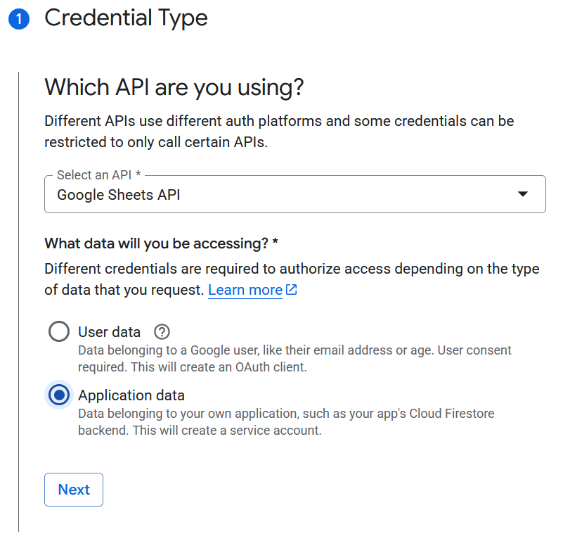

On the next screen set the following, then click “create and continue”

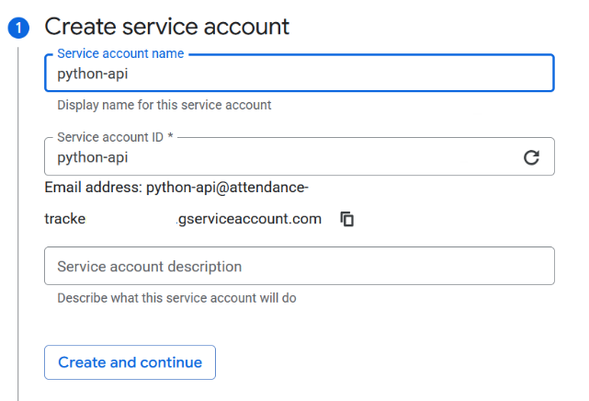

On the next screen in the “Select role” dropdown type “editor” then select the Editor entry from the drop down list” then click “continue” then finally “Done”.

Now we need to download the credentials we just created so click the “Credentials” tab in the middle of the window (NOT the Create Credentials we clicked earlier).

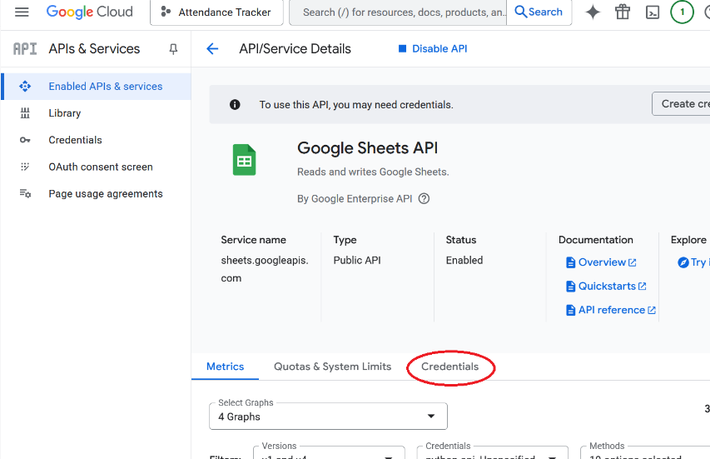

Then click on the “Service Account” we just created.

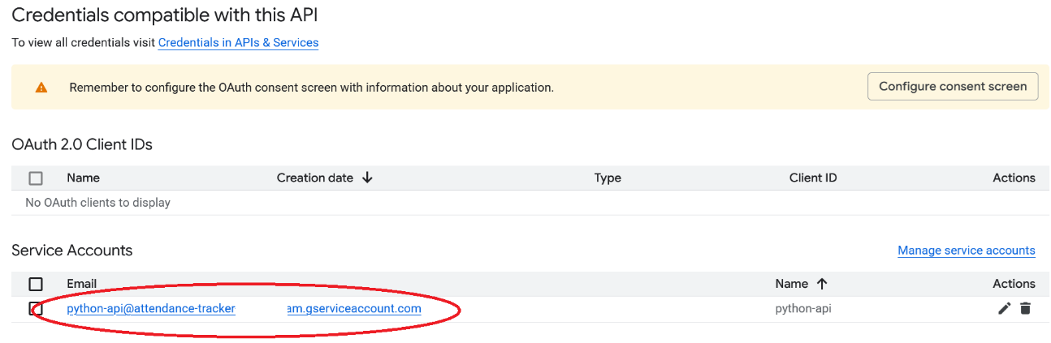

On the next screen click the tab “Keys”, then “Add key” and select “Create new key”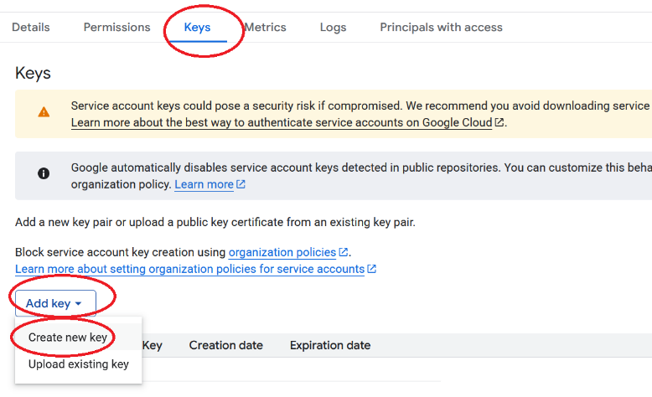

Ensure “JSON” is selected then click “Create”.

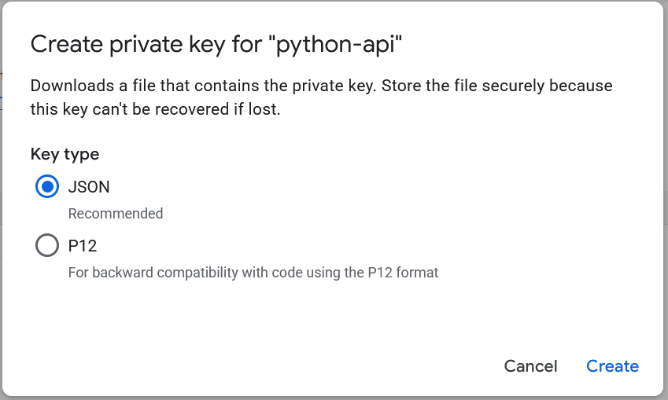

This will then save a file automatically to your computer. We need to copy this file to the same location where the Attendance Tracker Python file is located.

On Windows locate the file just downloaded (most likely it will be in your ‘downloads’ directory) and move it to the Attendance Tracker Python program location. Finally rename the file as “Credentials.json”.

NOTE : KEEP THIS FILE SAFE. DO NOT DISTRIBUTE IT TO ANYONE. THIS FILE CONTAINS THE KEYS TO ACCESS THE GOOGLE PROJECT WE JUST CREATED.

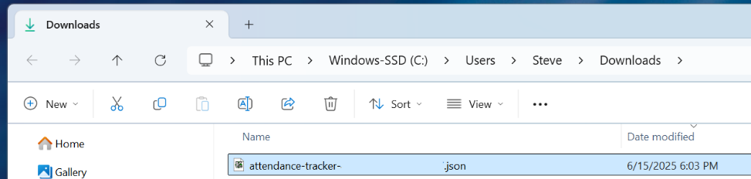

#### Workbook

Once you have a Google account activated that you want to use for your tracking database create a Google Sheet called “AttendanceTracker”. In this workbook name the first sheet “Members” and add a second sheet and name it “MasterActivity”

On the “Members” sheet add the following column headers, starting at cell A1…

“ID”, “Name”, “Type”, “Status”

On the “MasterActivity” sheet add the following headers, starting at cell A1…

“Date”, “ID”, “Action”

Eventually there will be a template workbook available to use as a starting point.

#### Google API access

In order for the Attendance Tracker to be able to talk to your Google Sheet workbook it is necessary to give it ‘permissions’ and a ‘key’. Unfortunately this process cannot be automated due to security concerns, but it is fairly straight forward.

For those interested in some of the details you can refer to this article, but don’t worry if not. (optional reading)

<https://developers.google.com/workspace/sheets/api/quickstart/python>

For access to a Google Sheet it needs to be part of a “Google Project” (More information here for those interested <https://developers.google.com/workspace/guides/create-project>)

##### Create a Google project

Given Google changes their web pages constantly the following instructions may not actually be correct. Sorry. Blame Google, not me 😊

##### Enable the API

## ToDo :

Encrypt the member name field and details

Encrypt the member photo

Create template Google Sheets workbook